Kamran Gul | CMS: 023-25-0161 | CS AI (C) | Lab # 14

Task 1:
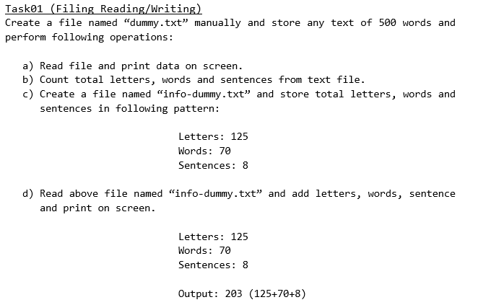
Solution:
#include <iostream>
#include <fstream>
#include <string>
using namespace std;
int main() {

//PART A
ifstream file1;
file1.open("dummy.txt");

if (!file1.is_open()) {
cout << "dummy.txt not found";
return 0;
}

string line;
string text = "";

while (getline(file1, line)) {
cout << line << endl;
text = text + line + " ";
}

file1.close();

//PART B
int letters = 0;
int words = 1;
int sentences = 0;

for (int i = 0; i < text.length(); i++) {

if ((text[i] >= 'a' && text[i] <= 'z') ||
(text[i] >= 'A' && text[i] <= 'Z')) {
letters++;
}

if (text[i] == ' ') {
words++;
}

if (text[i] == '.' || text[i] == '!' || text[i] == '?') {
sentences++;
}
}

//PART C
ofstream file2;
file2.open("info-dummy.txt");

file2 << "Letters: " << letters << endl;
file2 << "Words: " << words << endl;
file2 << "Sentences: " << sentences << endl;

file2.close();

//PART D
ifstream file3;
file3.open("info-dummy.txt");

string temp;
int L, W, S;

file3 >> temp >> L;
file3 >> temp >> W;
file3 >> temp >> S;

file3.close();

int total = L + W + S;

cout << endl;
cout << "Letters: " << L << endl;
cout << "Words: " << W << endl;
cout << "Sentences: " << S << endl;
cout << "Output: " << total << endl;

return 0;
}

Task 2:
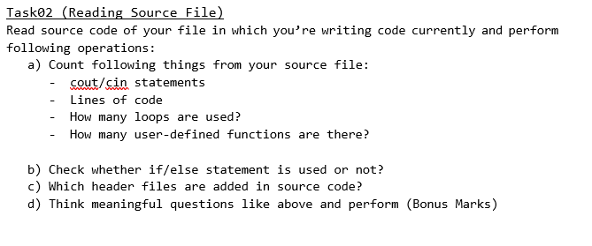
Solution:
#include <iostream>
#include <fstream>
#include <string>
using namespace std;
int main() {

ifstream file;
file.open("task2.cpp");

if (!file.is_open()) {
cout << "Source file not found";
return 0;
}

string line;

int coutCount = 0;
int cinCount = 0;
int loopCount = 0;
int functionCount = 0;
int ifCount = 0;
int elseCount = 0;
int headerCount = 0;
int lineCount = 0;

while (getline(file, line)) {

lineCount++;

if (line.find("cout") != -1) {
coutCount++;
}

if (line.find("cin") != -1) {
cinCount++;
}

if (line.find("for") != -1) {
loopCount++;
}

if (line.find("while") != -1) {
loopCount++;
}

if (line.find("do") != -1) {
loopCount++;
}

if (line.find("#include") != -1) {
headerCount++;
}

if (line.find("if") != -1) {
ifCount++;
}

if (line.find("else") != -1) {
elseCount++;
}

if (line.find("(") != -1 && line.find(")") != -1 &&
line.find("main") == -1 && line.find("#") == -1) {
functionCount++;
}
}

file.close();

cout << "cout statements: " << coutCount << endl;
cout << "cin statements: " << cinCount << endl;
cout << "Total lines of code: " << lineCount << endl;
cout << "Total loops: " << loopCount << endl;
cout << "User-defined functions: " << functionCount << endl;

if (ifCount > 0) {
cout << "If used: YES" << endl;
} else {
cout << "If used: NO" << endl;
}

if (elseCount > 0) {
cout << "Else used: YES" << endl;
} else {
cout << "Else used: NO" << endl;
}

cout << "Header files: " << headerCount << endl;

return 0;
}

Task 3:
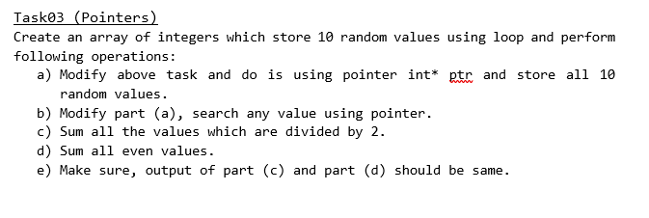
Solution:
#include<iostream>
using namespace std;
int main(){
int array[10];
int *ptr = array;

for(int i=0; i<10; i++){
cin>>*ptr;
array[i]=*ptr;
ptr+=1;
}
int search;
bool found = false;
int sum =0;
cout<<"Enter value to search: ";
cin>>search;
for(int i =0; i<10;i++){
if(search == array[i]){
found = true;
}
if(array[i]%2==0){
sum +=array[i];
}
}
if(found)
cout<<"Value found"<<endl;
else
cout<<"Value not found"<<endl;

cout<<endl<<"Sum of Numbers divided by 2: "<<sum<<endl;
cout<<endl<<"Sum of even numbers: "<<sum<<endl;

return 0;
}

